EXP NO: 7
DEMONSTRATE VIRTUALIZATION BY INSTALLING TYPE-2 HYPERVISOR
AIM
To demonstrate virtualization by installing a Type-2 hypervisor on a host device, creating and configuring a virtual machine with a guest operating system using VMware Workstation.
PROCEDURE
Step 1: Download and install VMware Workstation on the Windows host operating system.
Step 2: Download a Tiny Core Linux ISO image to use as the guest operating system.
Step 3: Open VMware Workstation and select Create a New Virtual Machine.
Step 4: Select the downloaded ISO image file and configure the virtual machine.
Step 5: Set the required hardware configuration such as:
- Memory: 2 GB
- Processor: 1 CPU
- Hard Disk: 20 GB
- Network: NAT
Step 6: Give the virtual machine a name, such as Tiny Core Linux.
Step 7: Click Finish to create the virtual machine.
Step 8: Power on the virtual machine and allow it to boot from the Tiny Core Linux ISO.
Step 9: Select Boot TinyCore from the boot menu.
Step 10: Verify that the Tiny Core Linux desktop is successfully displayed.

OUTPUT
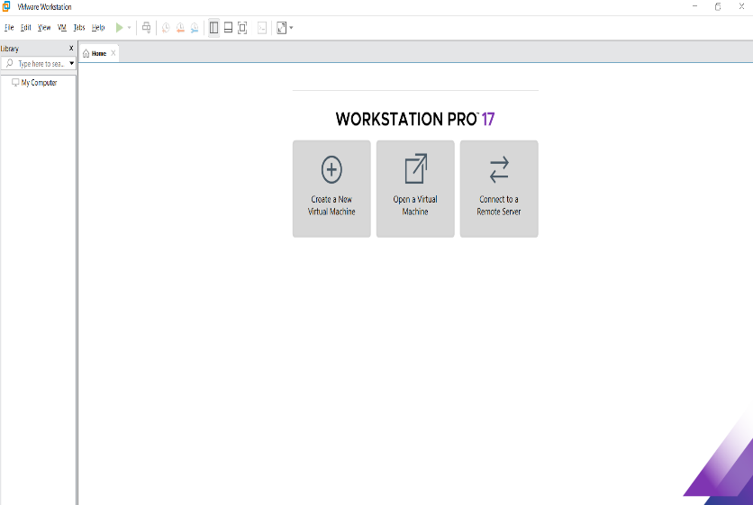

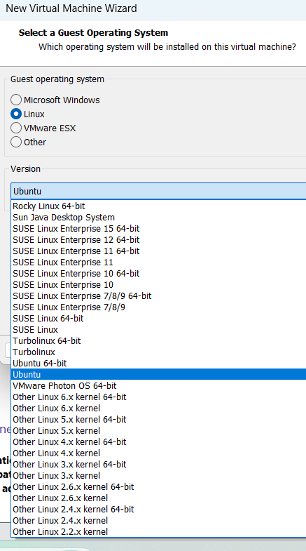

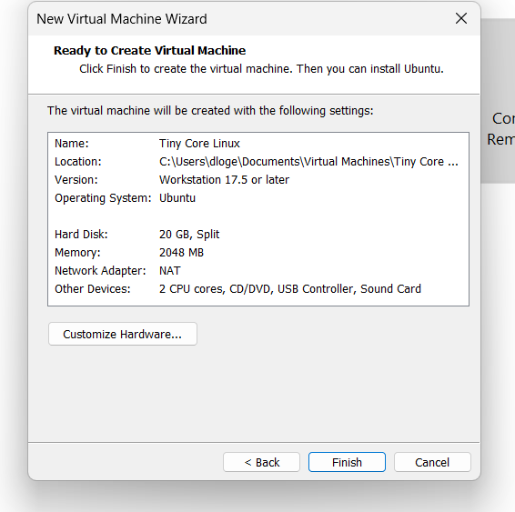

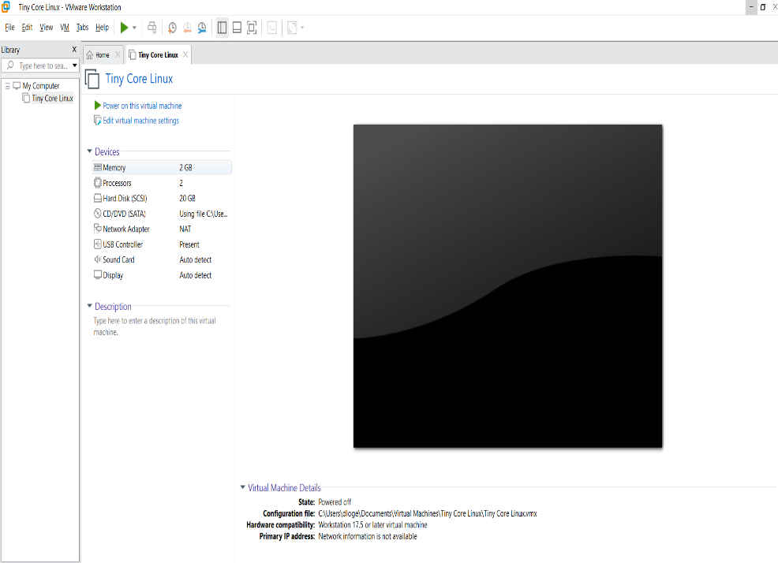

RESULT
The Tiny Core Linux virtual machine was successfully created, configured, and executed using VMware Workstation Type-2 hypervisor on the Windows host system.

